Common API Security Methods - HTTPS / TLS

🔐 What is HTTPS / TLS
# Source: AI Source: Provided by: [Data Path: Persons Table -> ID Column: 1, Name_En Column: Motasem Essam] -> From: [ChatGPT] on [1/19/2026]
HTTPS (HyperText Transfer Protocol Secure) uses TLS (Transport Layer Security) to encrypt communication between the API client and server.
👉 Think of HTTPS as a secure tunnel that protects data while it travels over the internet.

🔑 Key Concepts
# Source: AI Source: Provided by: [Data Path: Persons Table -> ID Column: 1, Name_En Column: Motasem Essam] -> From: [ChatGPT] on [1/19/2026]
- HTTPS = HTTP + TLS encryption
- TLS ensures:
  - 🔒 Confidentiality (no one can read the data)
  - 🛡️ Integrity (data is not modified)
  - ✅ Authentication (server identity is verified)

🧱 Example
# Source: AI Source: Provided by: [Data Path: Persons Table -> ID Column: 1, Name_En Column: Motasem Essam] -> From: [ChatGPT] on [1/19/2026]
❌ Without HTTPS (HTTP)
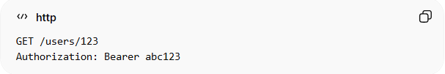
GET /users/123
Authorization: Bearer abc123
👉 Data is sent as plain text → can be intercepted 😨

✅ With HTTPS
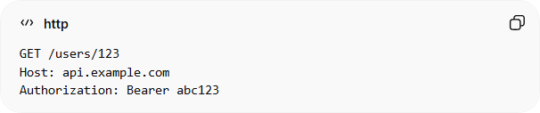
GET /users/123
Host: api.example.com
Authorization: Bearer abc123
👉 Data is encrypted → safe from attackers 🔐

⚙️ How TLS Works (Simplified)
# Source: AI Source: Provided by: [Data Path: Persons Table -> ID Column: 1, Name_En Column: Motasem Essam] -> From: [ChatGPT] on [1/19/2026]
- Client connects to server using HTTPS
- Server sends SSL/TLS certificate
- Client verifies certificate (trusted authority)
- Secure encrypted connection is established
- Data is exchanged securely

🔒 What HTTPS Protects
# Source: AI Source: Provided by: [Data Path: Persons Table -> ID Column: 1, Name_En Column: Motasem Essam] -> From: [ChatGPT] on [1/19/2026]
- API keys
- OAuth tokens / JWT
- User credentials (username/password)
- Request & response data

✅ Advantages
# Source: AI Source: Provided by: [Data Path: Persons Table -> ID Column: 1, Name_En Column: Motasem Essam] -> From: [ChatGPT] on [1/19/2026]
- Protects data from eavesdropping (MITM attacks)
- Ensures secure communication
- Required for modern apps and browsers
- Improves trust and security compliance

❌ Disadvantages
# Source: AI Source: Provided by: [Data Path: Persons Table -> ID Column: 1, Name_En Column: Motasem Essam] -> From: [ChatGPT] on [1/19/2026]
- Slight performance overhead (usually negligible today)
- Requires certificate setup and management

⚠️ Common Mistakes
# Source: AI Source: Provided by: [Data Path: Persons Table -> ID Column: 1, Name_En Column: Motasem Essam] -> From: [ChatGPT] on [1/19/2026]
- Using HTTP instead of HTTPS ❌
- Accepting invalid/self-signed certificates in production ❌
- Not enforcing HTTPS (allowing downgrade attacks) ❌

🔐 Best Practices
# Source: AI Source: Provided by: [Data Path: Persons Table -> ID Column: 1, Name_En Column: Motasem Essam] -> From: [ChatGPT] on [1/19/2026]
- Always use HTTPS for all API endpoints
- Redirect all HTTP traffic → HTTPS
- Use strong TLS versions (TLS 1.2 or 1.3)
- Regularly renew SSL certificates
- Use HSTS (HTTP Strict Transport Security)

💡 Key Idea
# Source: AI Source: Provided by: [Data Path: Persons Table -> ID Column: 1, Name_En Column: Motasem Essam] -> From: [ChatGPT] on [1/19/2026]
HTTPS/TLS secures the communication channel, ensuring that all API data is encrypted, safe, and trusted during transmission.

🧾 Important Insight
# Source: AI Source: Provided by: [Data Path: Persons Table -> ID Column: 1, Name_En Column: Motasem Essam] -> From: [ChatGPT] on [1/19/2026]
Even if you use API Keys, OAuth, or JWT, they are NOT secure without HTTPS

